بسم الله الرحمن الرحيم

King Saud University
College of Engineering
Civil Engineering Department

SE 365: “Principles of Remote Sensing & Image Interpretation”
1444H 1st Semester

Homework #7 Solutions

Q1: Explain briefly the elements that should be addressed in image interpretation for terrain evaluation. (Illustrate your answer using sketches).
Answer;
5-key elements that are studies stereoscopically. These elements are topography, drainage pattern & texture, erosion, image tone, vegetation & land use.
Topography; each landform & bedrock type has its own characteristic topographic form that has typical size & shape.
Drainage pattern &texture; there are 6 common drainage patterns, these are; (1) dendritic drainage pattern, a well-integrated pattern formed by main stream branching freely in all directions in homogenous material such as horizontal bedded sedimentary rock & granite. (2) Rectangular drainage pattern, basically a modified dendritic pattern occurs in flat-laying massive sandstone. (3) Trellis drainage pattern, occurs in areas of folded sedimentary rocks. (4) Radial drainage pattern, typical of volcanoes & domes. (5) Centripetal drainage pattern, occurs in areas of limestone & other depressions. (6) Deranged drainage pattern, aimlessly directed short streams occurs in wetland areas. Similarly; there are two drainage textures, these are; (1) Course-textured drainage pattern, developed at hard massive rocks, such as sandstone, where the soils & rocks have good internal drainage with little surface runoff. (2) Fine-textured patterns, occurs at soft easily eroded rocks, such as shale, where soils & rocks have poor internal drainage & high surface runoff.

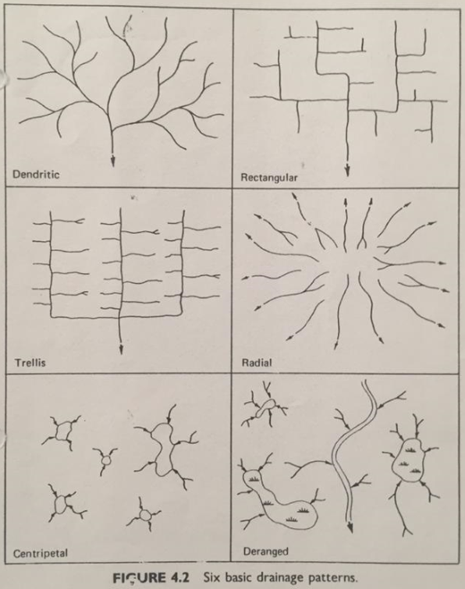

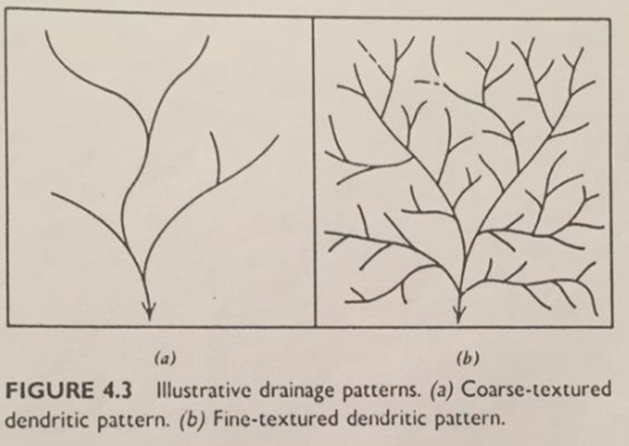
Erosion; result from the erosion of unconsolidated materials by runoff, gullies are the smallest drainage features that can be seen on aerial photographs. Gullies can be as small as 1 meter wide & 100 meter long. The gullies shape is a characteristic of the material in which they are formed. Three common gullies shapes; (1) Short V-shape cross-sectioned gullies tend to develop in sand & gravel; (2) U-shape cross-sectioned gullies tend to develop in a silty soils; (3) long-gullies with gently rounded cross-sectioned tend to develop in silty & clay soils.

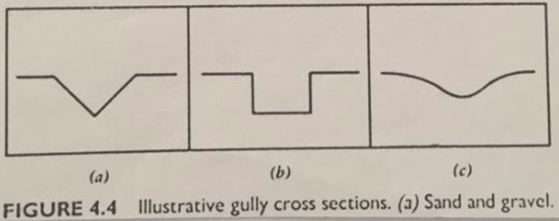

Image Tone; refers to the relative brightness or color of objects in an image.
Vegetation & land use; differences in vegetation often indicate differences in terrain conditions. However, in many cases vegetation & land use obscure differences in terrain conditions.

Q2: Explain briefly the main differences in image identification between horizontal bedded sandstone & granitic rocks.

Answer;

The principal differences in image identification of granitic rocks versus sandstone can be summarized as follows;
 | Granite | Sandstone
1 - Evidences of bedding  2 – Topography  3 - Joint pattern  4-Drainage pattern | None.  Variable summit.  Rounded cliffs.  Rounded micro-features.  Irregular joint pattern.  Dendritic | Bedded.  Forms plateaus.  Vertical cliffs.  Blocky micro-features.  Joint system consisting of 2 or 3 principal directions.  Rectangular

Q3: Explain briefly the main differences in image identification between sandstone capped plateaus & flood basalt plateaus.

Answer;

The principal differences in image identification of flood basalt plateaus versus sandstone capped plateaus can be summarized as follows;
 | Flood Basalt Plateaus | Sandstone Capped Plateaus
1 - Tone  2 – Rock jointing  3 - Drainage | Dark-toned.  Columnar jointing.  Cliff edges have a serrated appearance.  Principally internal drainage. | Light-toned.  Joint system consisting of 2 or 3 principal directions. Canyon & cliff edges.  Has a law density modified dendratic pattern.

Q4: Explain briefly the different types of sand dunes formations.

Answer;

Sand dunes vary in shape, depending on the quantity & particle size of the sand, the strength & direction of the wind, & the vegetation conditions, &
Basic sand dunes shapes;
  - Transverse sand dunes;
    - Tend to form in areas with a large supply of sand & little vegetation, &
    - Often cover large areas & develop a wave-like perpendicular to the direction of the wind.
  - Barchans dunes;
    - Crescent-shaped dunes,
    - Tend to form in areas where there is a limited amount of sand & little vegetation, &
    - The tips of the dunes point downwind.
  - Parabolic sand dunes;
    - Have a crescent shape with long horns pointed into the wind, &
    - Formed where vegetation anchors portions of the horns, allowing the center to migrate.
  - Longitudinal sand dunes;
    - long, nearly straight ridges of sand that form parallel to the direction of the wind, &
    - Symmetrical with a width several times the height.

